**Abhijit Turate - 70**

**Priyanka Shinde - 71**

**Kesha Mehta- 74**

**Aim: Data Analysis on customer segmentation using K-means.**

**Theory:**

**Machine Learning:**

Machine learning is an application of artificial intelligence (AI) that provides systems the ability to automatically learn and improve from experience without being explicitly programmed. Machine learning focuses on the development of computer programs that can access data and use it to learn for themselves.

The process of learning begins with observations or data, such as examples, direct experience, or instruction, in order to look for patterns in data and make better decisions in the future based on the examples that we provide. The primary aim is to allow the computers learn automatically without human intervention or assistance and adjust actions accordingly.

**K-Means:**

**Kmeans** algorithm is an iterative algorithm that tries to partition the dataset into Kpre-defined distinct non-overlapping subgroups (clusters) where each data point belongs to **only one group**. It tries to make the intra-cluster data points as similar as possible while also keeping the clusters as different (far) as possible. It assigns data points to a cluster such that the sum of the squared distance between the data points and the cluster’s centroid (arithmetic mean of all the data points that belong to that cluster) is at the minimum. The less variation we have within clusters, the more homogeneous (similar) the data points are within the same cluster.

**How the K-means algorithm works**

To process the learning data, the K-means algorithm in data mining starts with a first group of randomly selected centroids, which are used as the beginning points for every cluster, and then performs iterative (repetitive) calculations to optimize the positions of the centroids

It halts creating and optimizing clusters when either:

* The centroids have stabilized — there is no change in their values because the clustering has been successful.
* The defined number of iterations has been achieved.

**Code & Output:-**

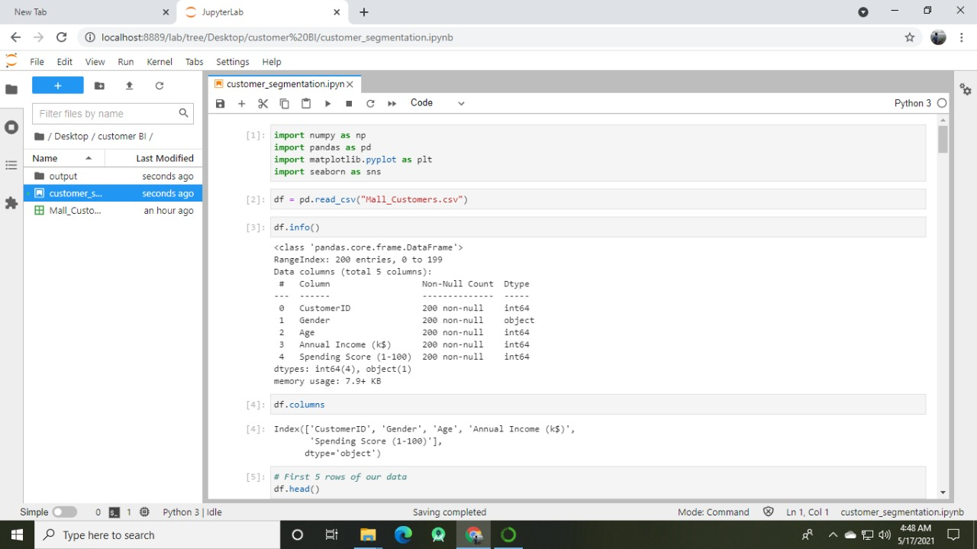

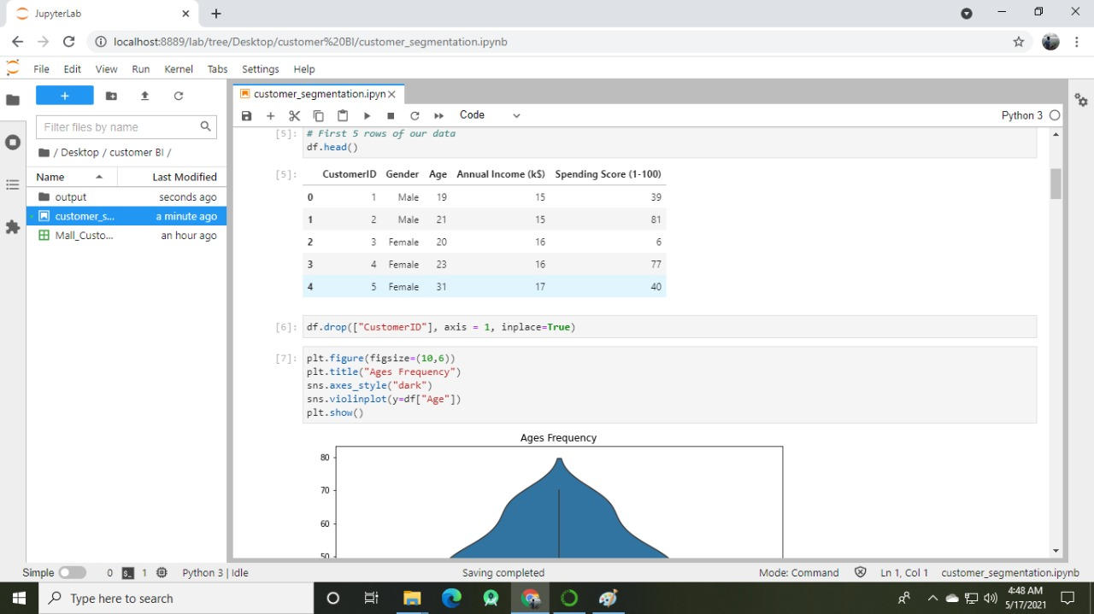

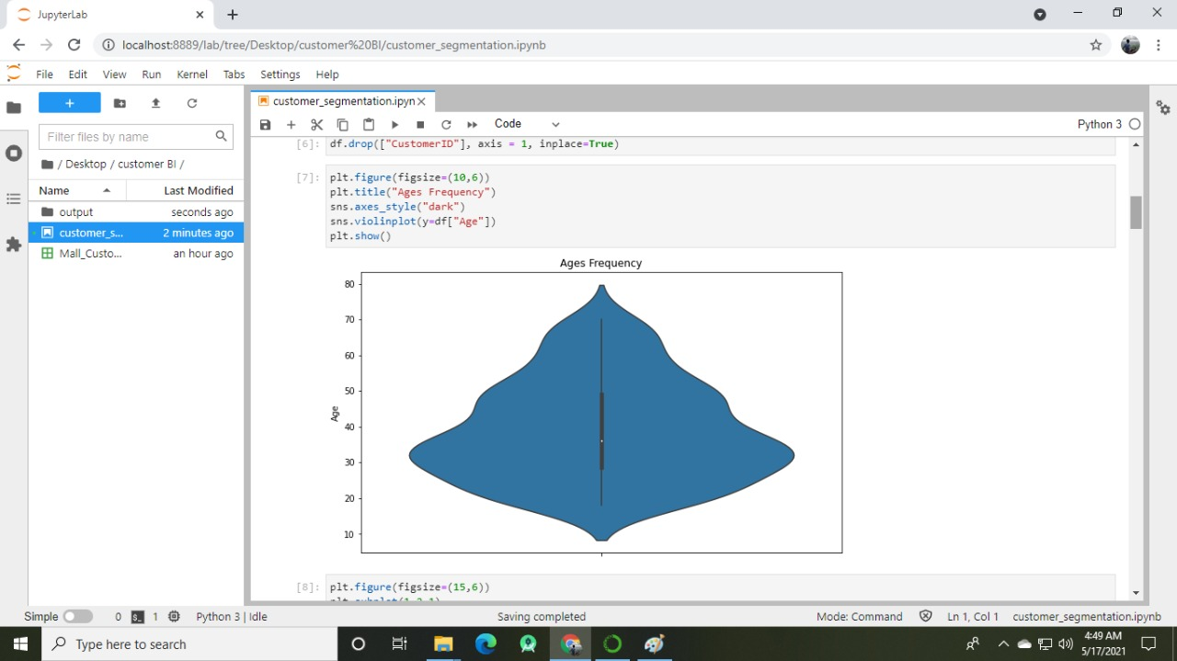

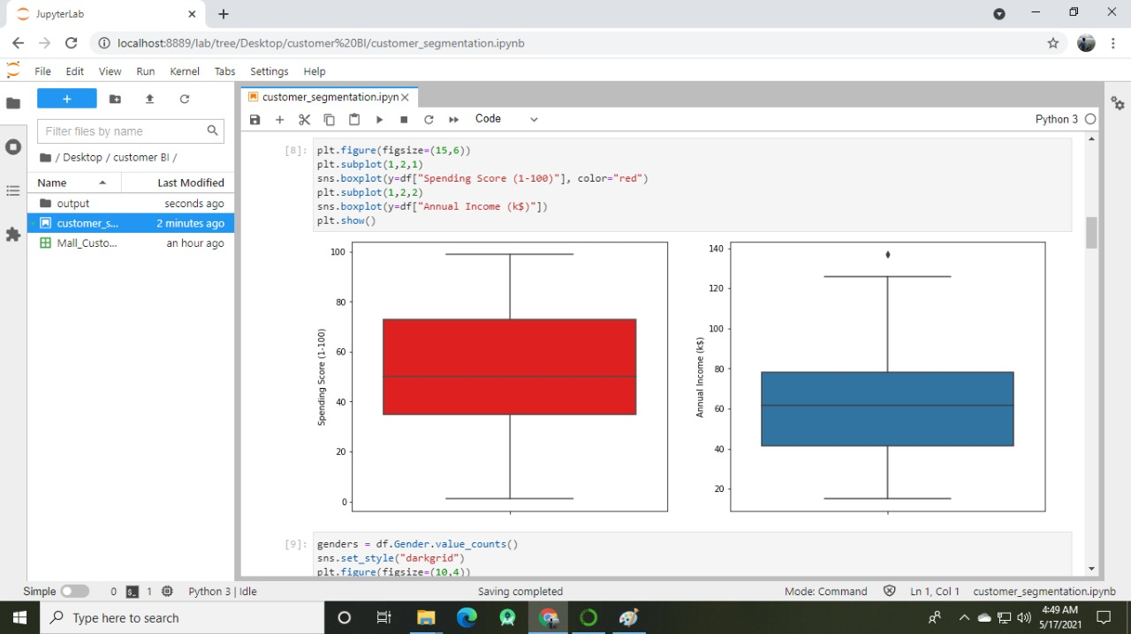

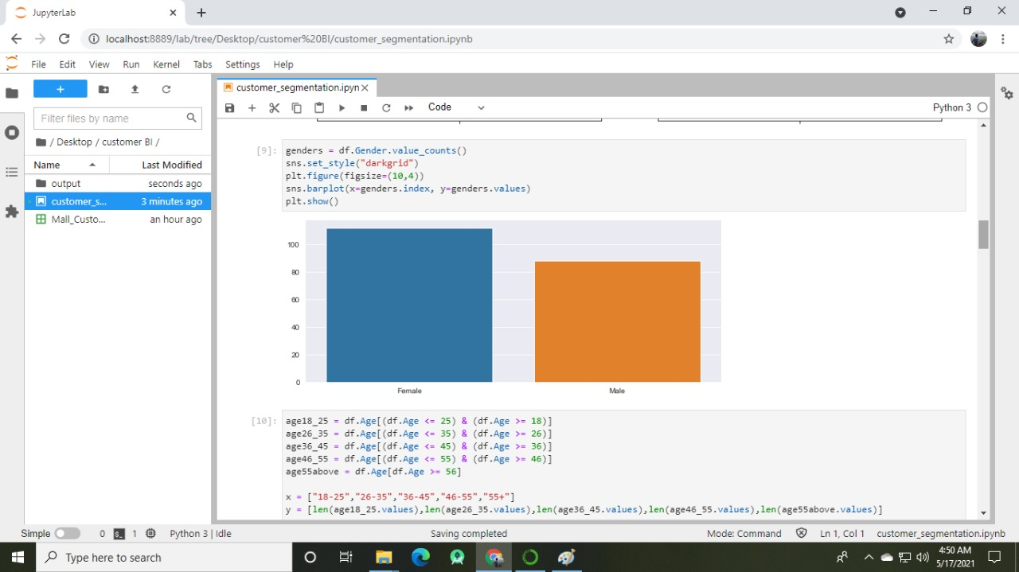

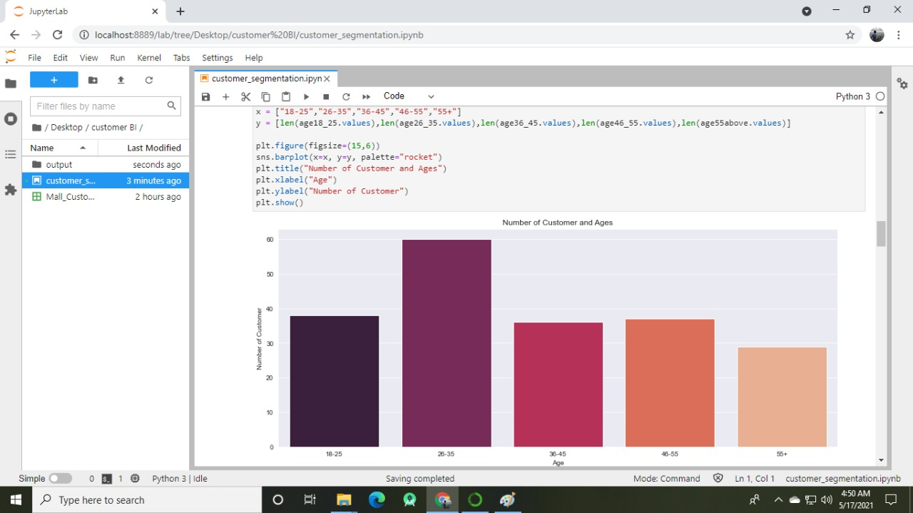

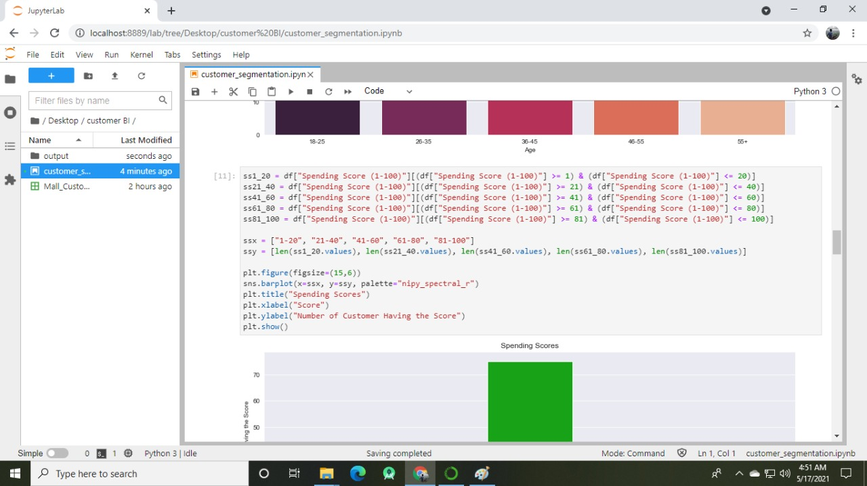

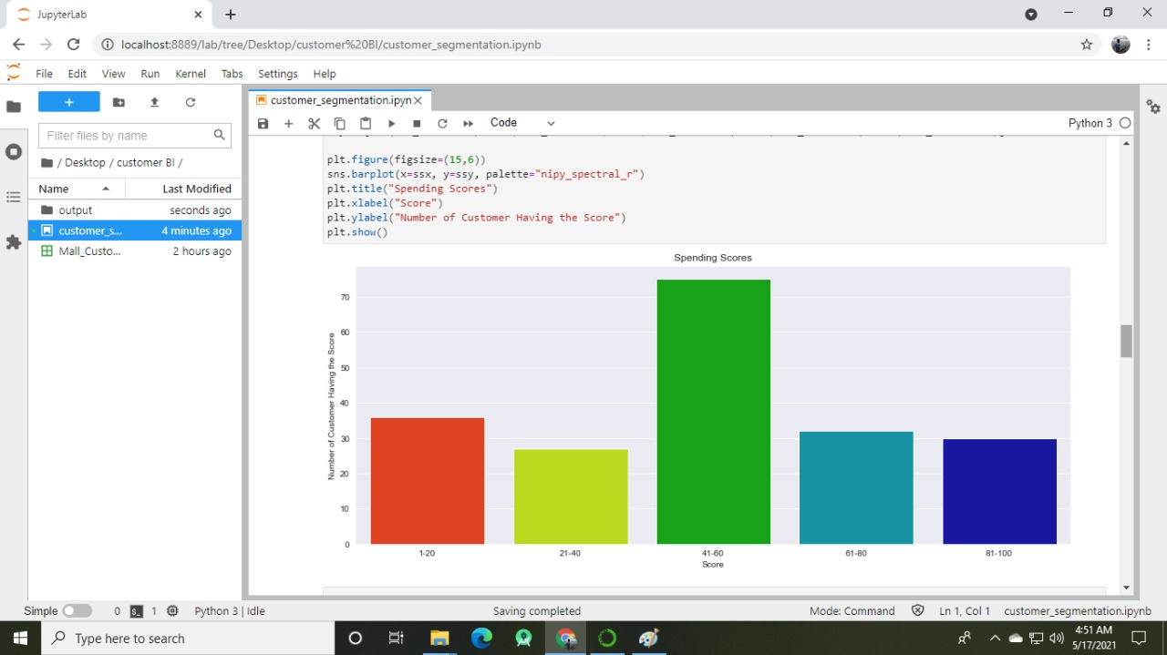

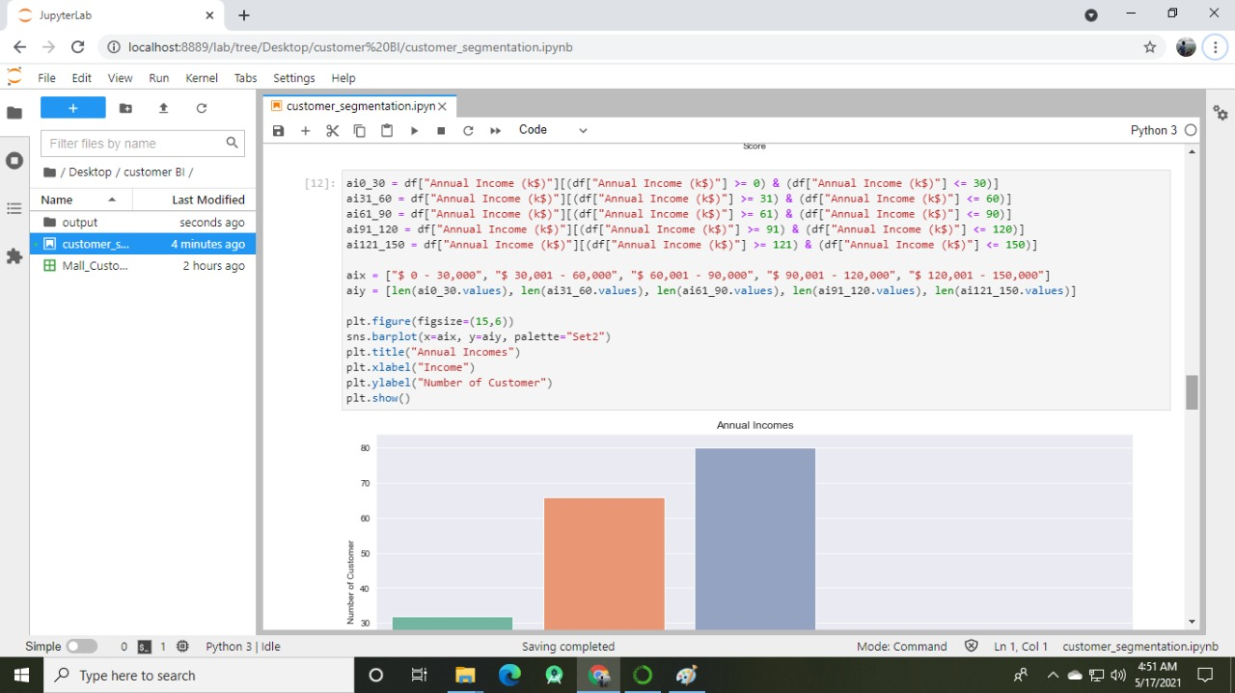

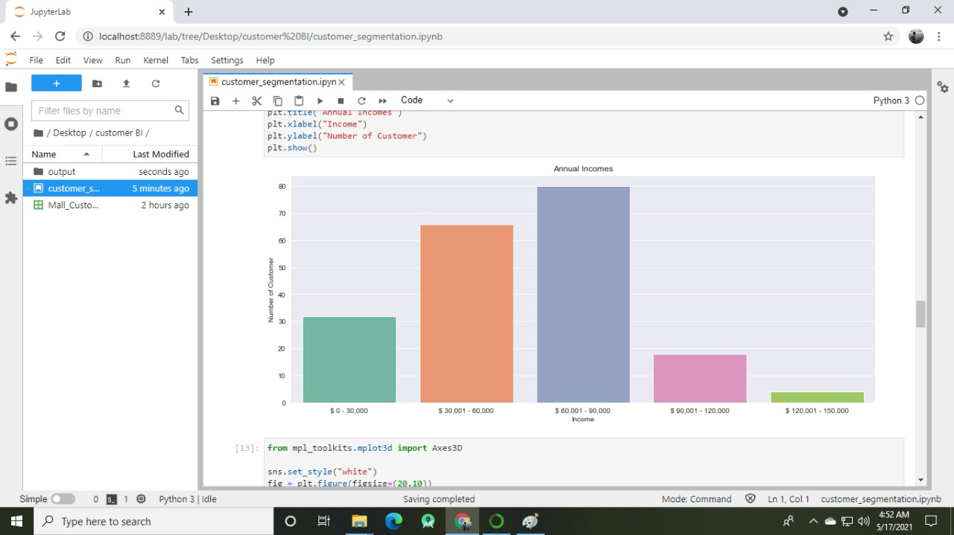

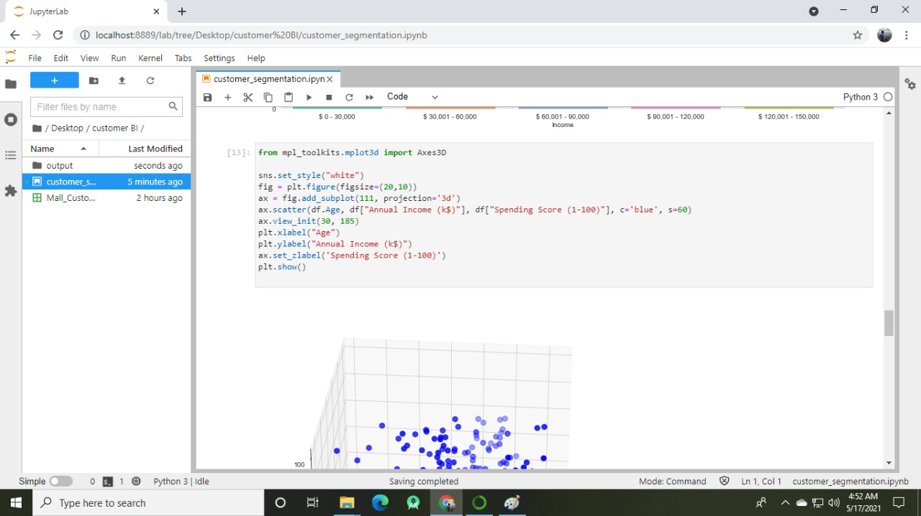

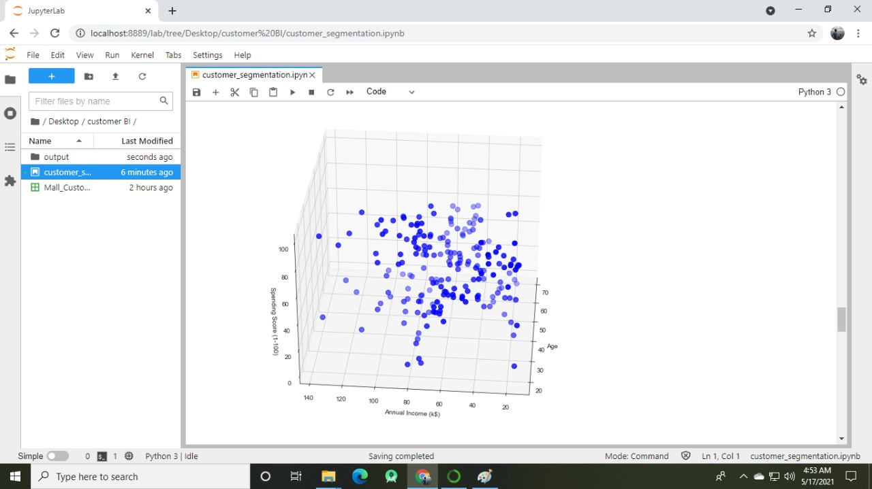

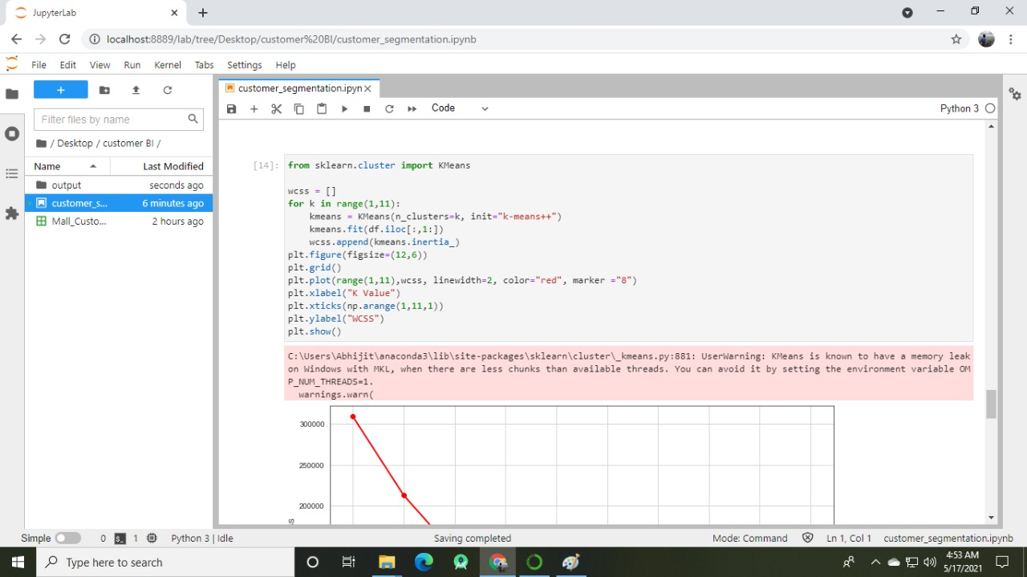

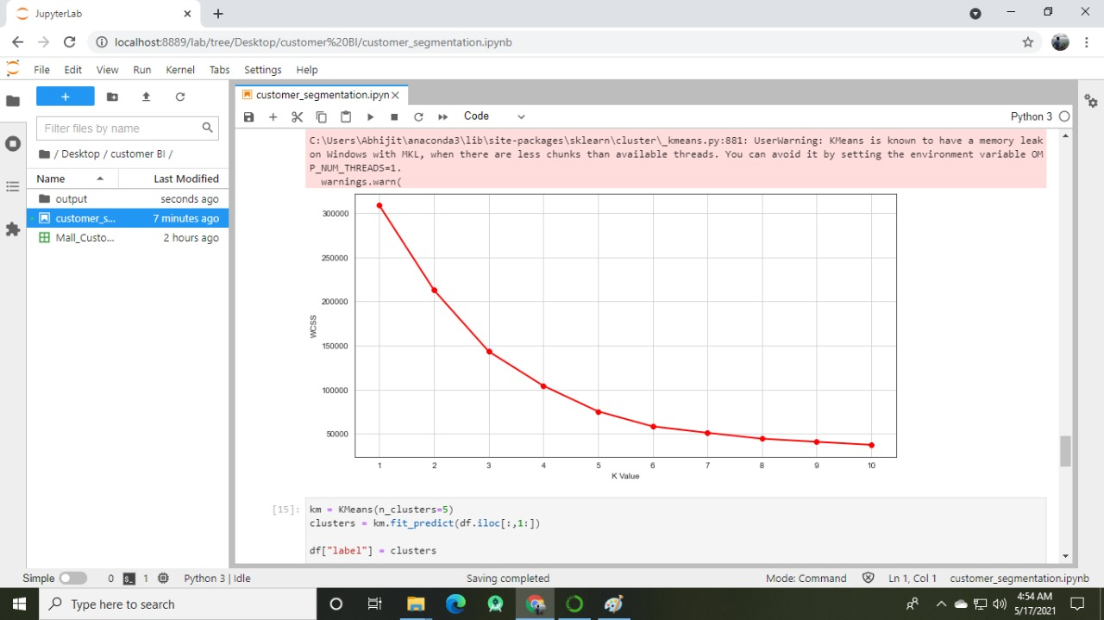

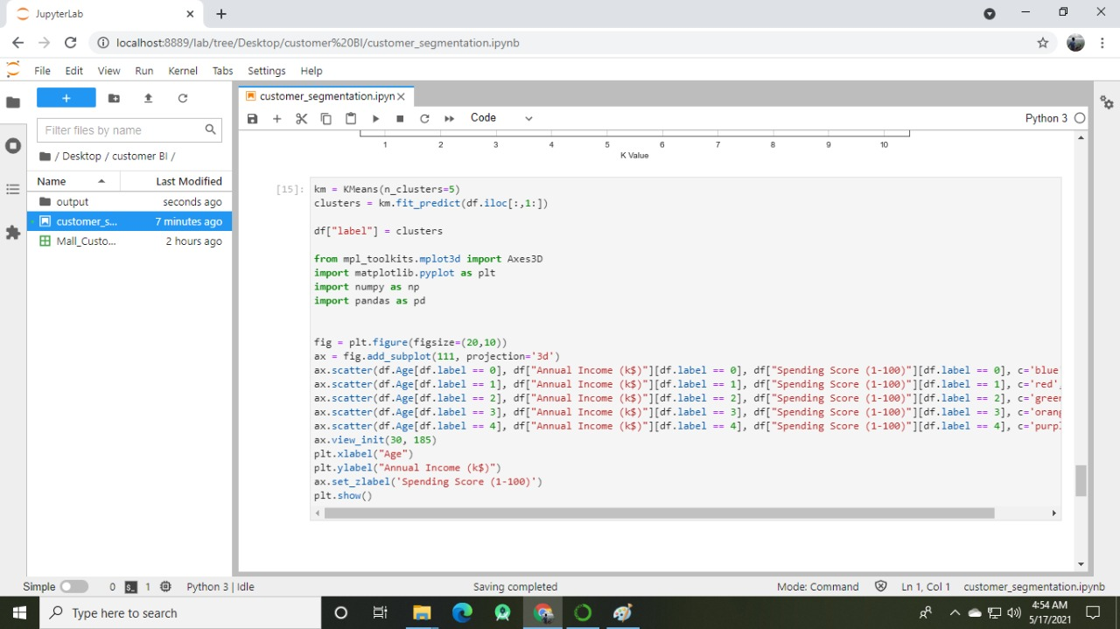

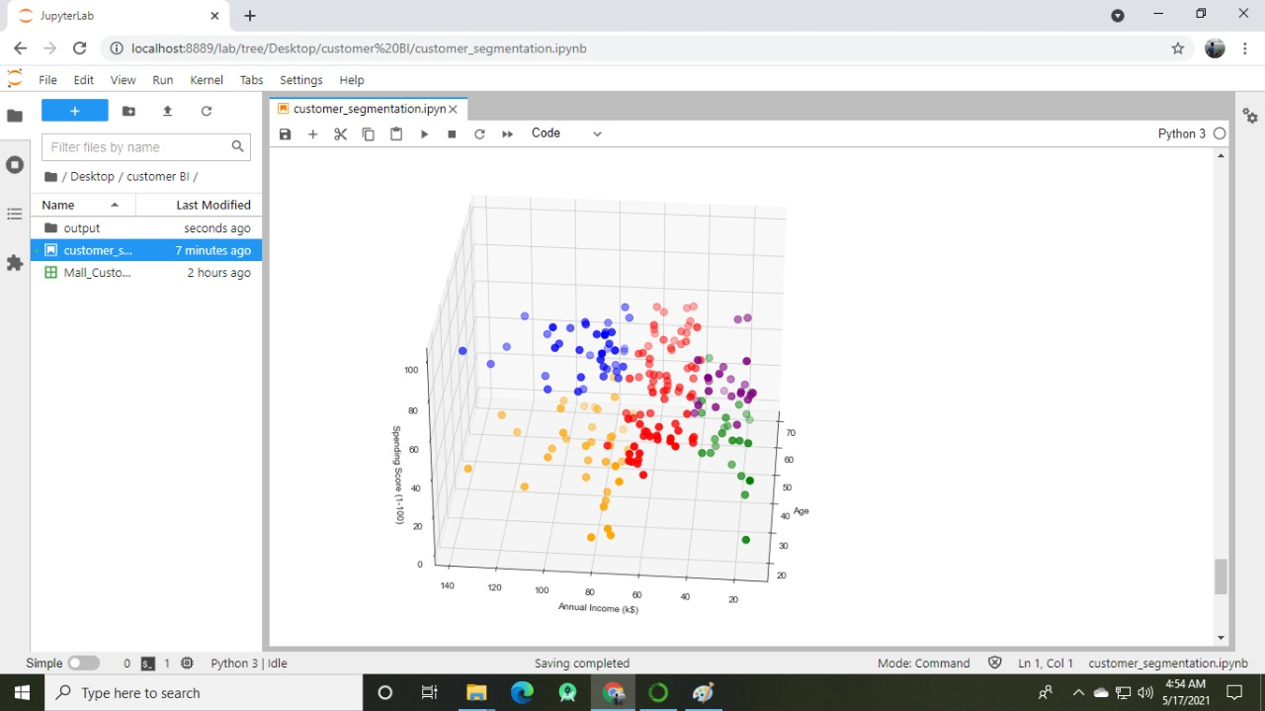

**Result:-We have successfully analyzed data on costumer segmentation using K-means.**